

|  |  |  |  |  |  |  |  |
| --- | --- | --- | --- | --- | --- | --- | --- |
|  | | | | | | | |
|  | 7PAM2000 Applied Data Science 1 Assignment 1: Visualization | | | | | |  |
|  |  | | | | |  | |
|  | | |  |  | | | |
|  | | | Muhammad Omer Akram |  | | | |
|  | | | 11th November, 2023—Applied Data Science 1—Ralf Napiwotzki |  | | | |
|  | |  | | |  | | |

##### Link to GitHub Repository

<https://github.com/muhammadomer1live/AP1_Assignment1.git>

##### References to CSV Datasets

(US_Crime_Rates_1960_2014) - [link](https://www.kaggle.com/datasets/mahmoudshogaa/us-crime-rates-1960-2014)

(American Citizens Annual Income) - [link](https://www.kaggle.com/datasets/amirhosseinmirzaie/americancitizenincome)

(Operating System Market Share Worldwide - October 2023) - [link](https://gs.statcounter.com/os-market-share#monthly-202301-202310)

##### VISUALIZATION 01

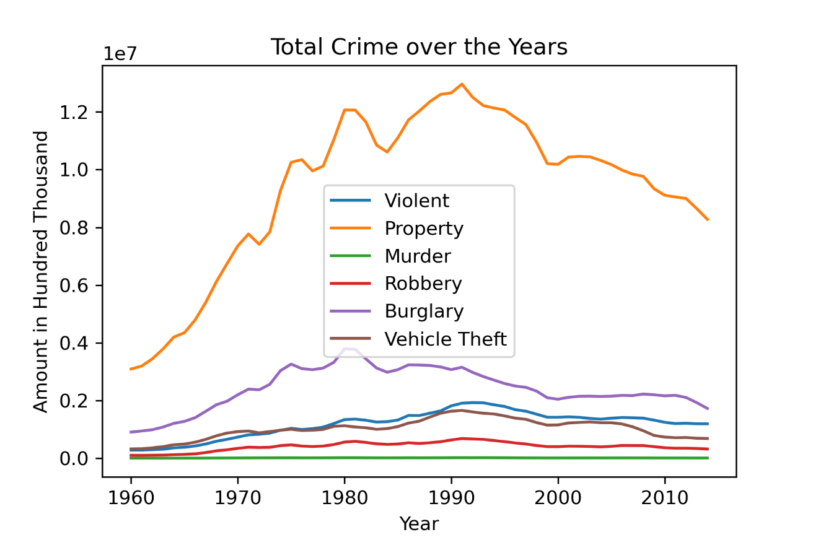

**Line graphs**

Used to visualize changes in data over time. They are a simple and effective way to show trends and patterns in data.

Conclusions

Conclusions from a line plot of total number of crimes in the US by type of crime by year from 1960 to 2014:

* Overall crime rates have declined significantly in the US since 1990s. This is true for both violent and property crimes.
* Murder rates have declined followed by robbery, aggravated assault, and burglary.
* Vehicle theft rates have remained relatively stable.
* Violent crime rates peaked in the early 1990s and have been declining steadily since then.
* Property crime rates have also declined significantly since 2000s after peaking in the 1990s. This is true for all types of property crime, including burglary and vehicle theft.
* The decline in crime rates has been attributed to a number of factors, including changes in policing strategies, demographics, and economic conditions.

##### VISUALIZATION 02

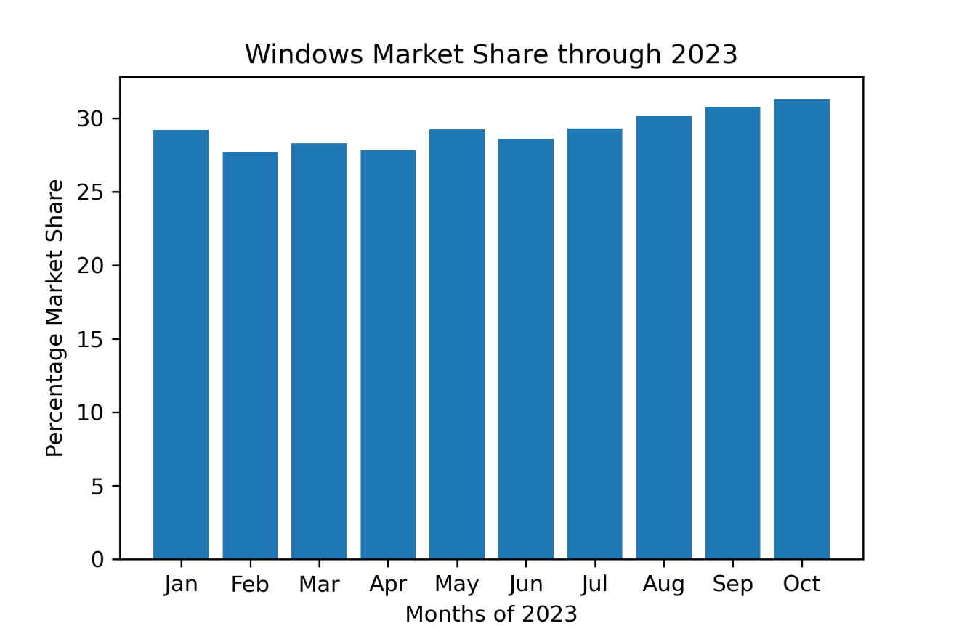

**Bar graphs**

A bar graph is a good way to represent the data you have provided because it is a simple and effective way to compare different categories of data. Bar graphs are easy to read and interpret, and they can be used to show trends over time.

Conclusions

Based on the bar graph of Windows operating system market share from January to December of 2023, the following conclusions can be drawn:

* Windows has a relatively stable market share, fluctuating between 27.71% and 31.28% throughout the year.
* Windows market share peaked in October 2023 at 27.71% and bottomed out in February 2023 at 27.71%.
* Windows market share increase in the later half of 2023 also show a growing trend showing positive outlook for the investors.
* Overall, Windows remains one of the most popular operating system in the world, with a market share of over 30%.

##### VISUALIZATION 03

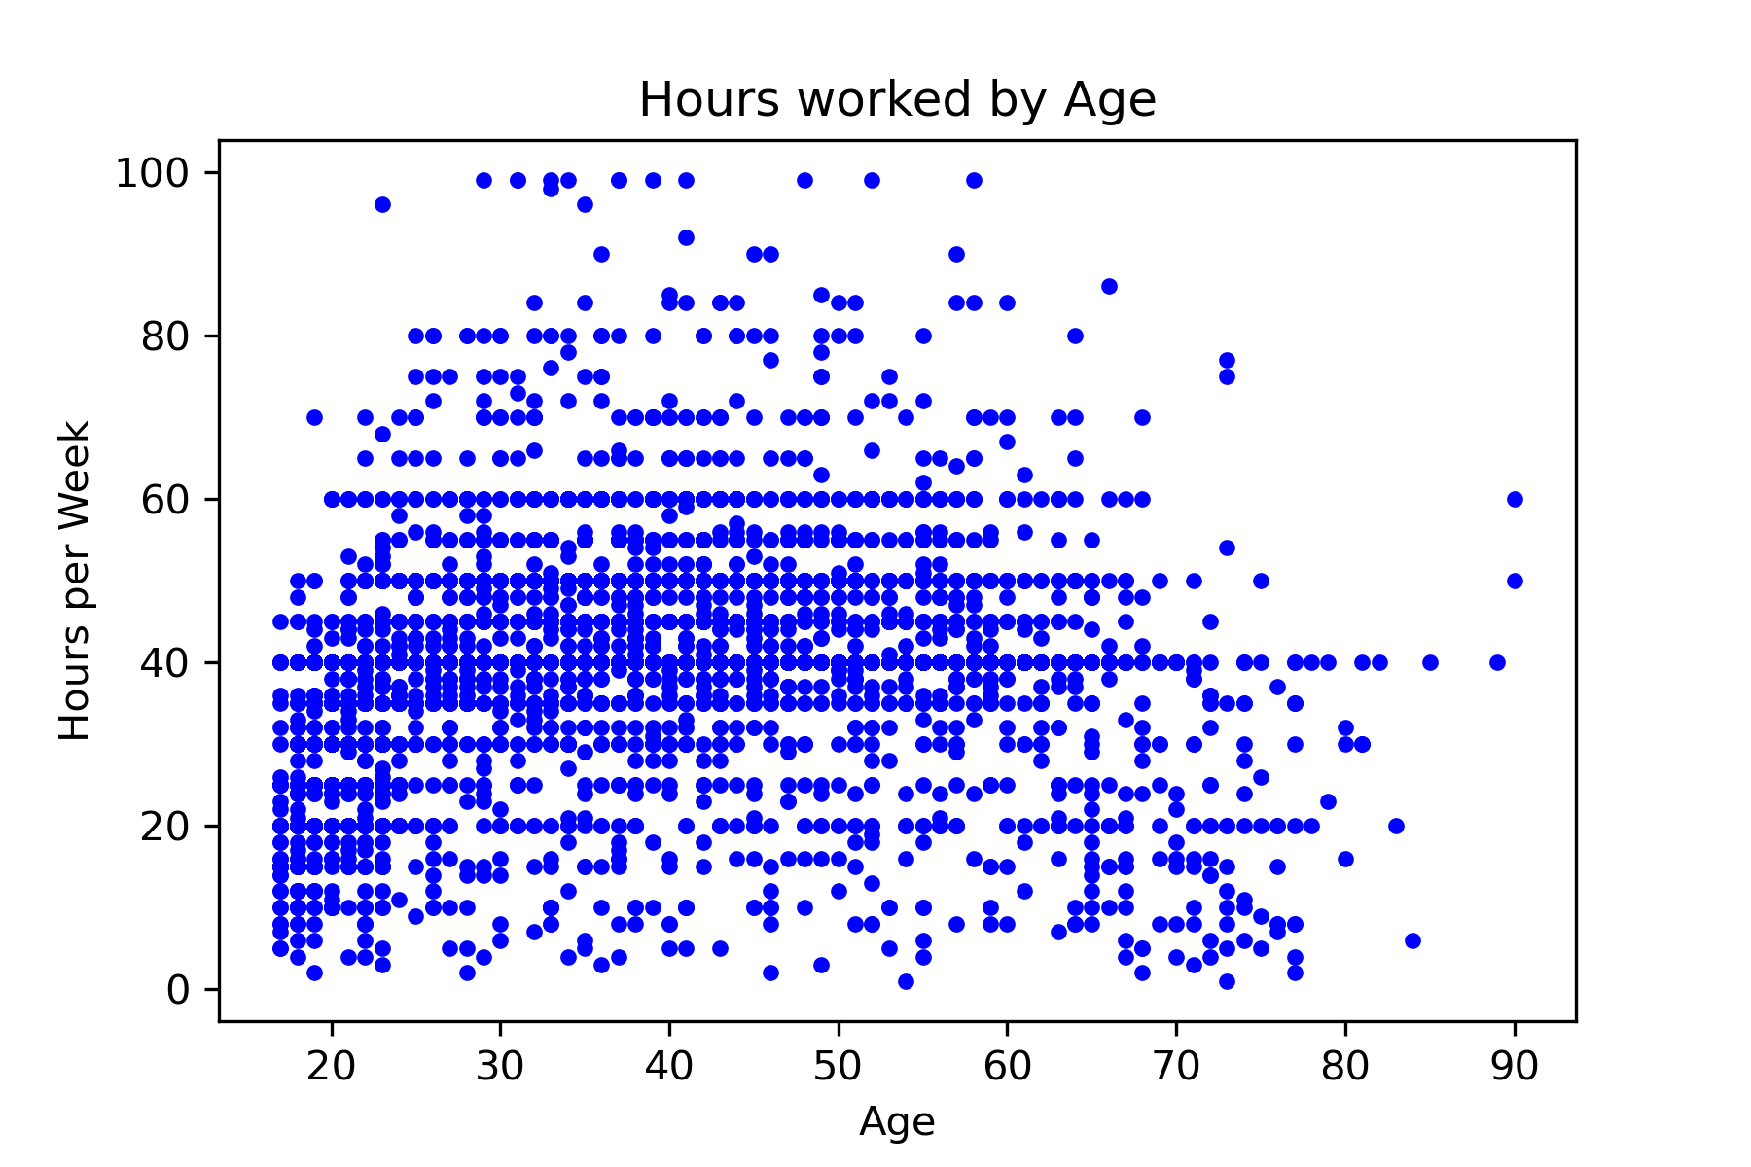

**Scatter Plots**

Scatter plots can be used to identify relationships between two variables, such as whether there is a positive correlation, negative correlation, or no correlation at all. Scatter plots can also be used to identify outliers and patterns in the data.

Conclusions

The scatter plot shows a negative correlation between age and hours worked per week. This means that as age increases, hours worked per week tends to decrease.

Here are some specific conclusions that can be drawn from the scatter plot:

* Older people tend to work fewer hours per week than younger people.
* The decline in hours worked per week with age is relatively gradual.
* There is a wide range of hours worked per week at all ages.
* There are a few outliers in the data, such as people who work very long hours at older ages or people who work very few hours at younger ages.